

Complete Test Protocols & SOP
(CC, CV, SOC, SOE, CR, DCIR)

Data | 19.09.2025
Version | 01
Prepared by
Battery Test Engineer | Zawar Qureshi
Agreed by
Electrochemical Research Engineer | Dmitrii Makhov

Contents
0) Cell, Blocks, Limits, and Global Assumptions 3
1) Conversion: Current Density ↔ Current (173.24 cm²) 7
2) Recommended Overall Order of Testing for Cells 7
3) Pre‑Conditioning & Basic Handling 7
4) Primary Objective — EDLC Region & Redox Onset 8
4A) Multi‑Rate CV with Capacitive Scaling 8
4B) Low‑Rate GCD with Differential Capacitance 9
5) Low‑Rate Reference Capacity/Energy (Defines (Q_{ref}, E_{ref}), Build OCV-SOC and SOE map, Determine DC ESR_{10ms} and DC ESR_{1s}) 10
6) DCIR at Multiple SOC (Time‑Domain Resistance) 11
7) Capacity Retention (CR) Long Cycling 12
8) Copy‑Paste Cycler Programs (Pseudocode Style) 13

0) Cell, Blocks, Limits, and Global Assumptions
- Cell geometry: 160 × 140 mm; slurry‑coated active area: 142 × 122 mm = 173.24 cm² (for current‑density calculations). Stacked positive/negative electrodes with separator, compressed in a steel fixture. Terminals are tin-coated copper current-collector tabs (integral to the collectors), each tab 20 mm × 50 mm (Figure 1). Copper current-collector is not to be confused with normal current-collectors that are coated with slurry. The copper current-collector (50 microns) with tabs is only used as terminals.
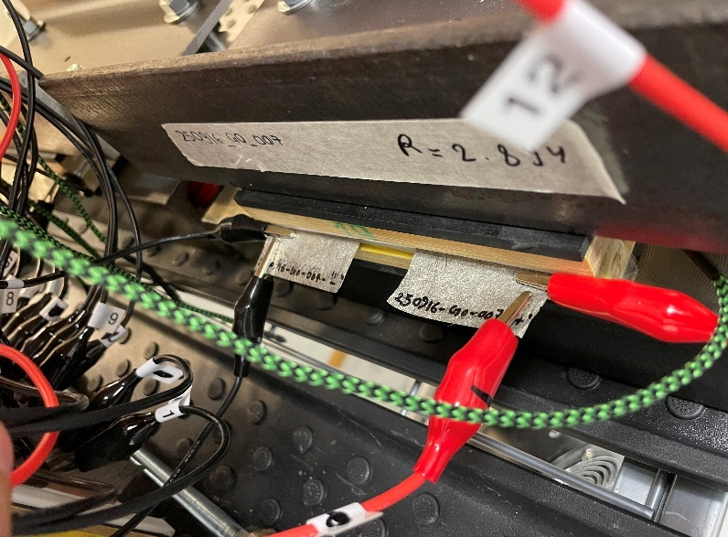
Figure 1: Assembled Single-Cell.
- Block geometry: Multiple cells in series under the same style of steel compression fixture, Figure 2. No copper tabs: instead, aluminum radiators at the top and bottom serve as the positive and negative terminals.
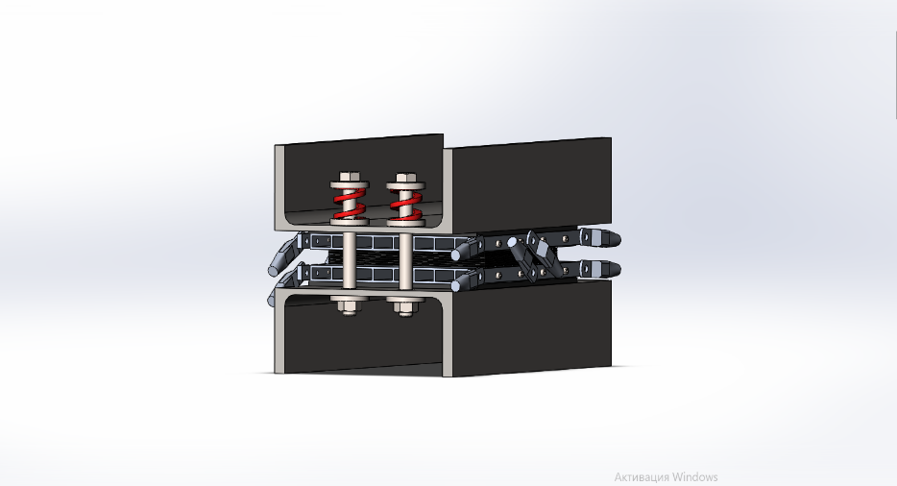
Figure 2: Block Fixture.
- Nominal operating voltage window: 0.85 → 1.70 V (one cell).
- Equipment:
  - 12-Channel Cycler (Figure 3): Voltage operating range of 0.1 V to 20 V and current operating range of 10 mA to 10 A. Multiple channels can be connected in parallel to deliver higher currents. No GANG mode for parallel operation. 4-wire (force/sense), each wire terminated with kelvin clamps, 100 Hz sampling.
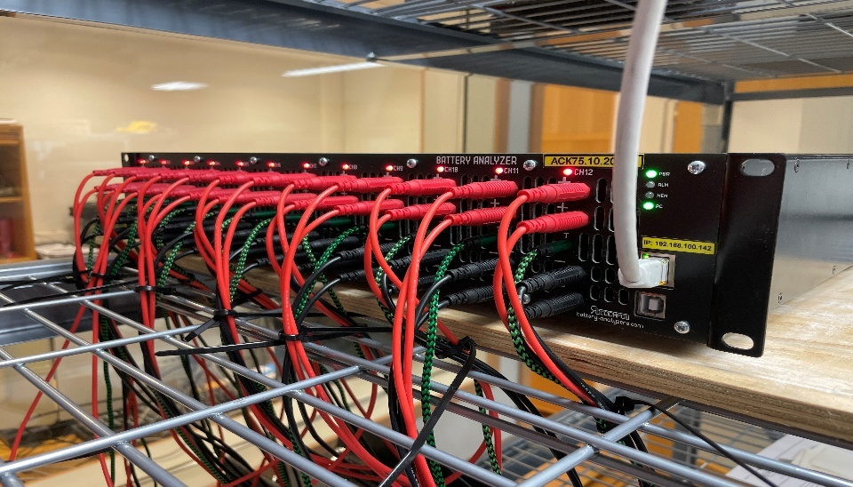
Figure 3: Multi-Channel Cycler ACK75.10.20.12.
  - Single Channel Cycler (Figure 4): Voltage operating range of 1 V to 56 V and current operating range of 2 A to 75 A. 4-wire (force/sense), force wires terminated with lugs and sense wires terminated alligator clips, 10 Hz sampling.
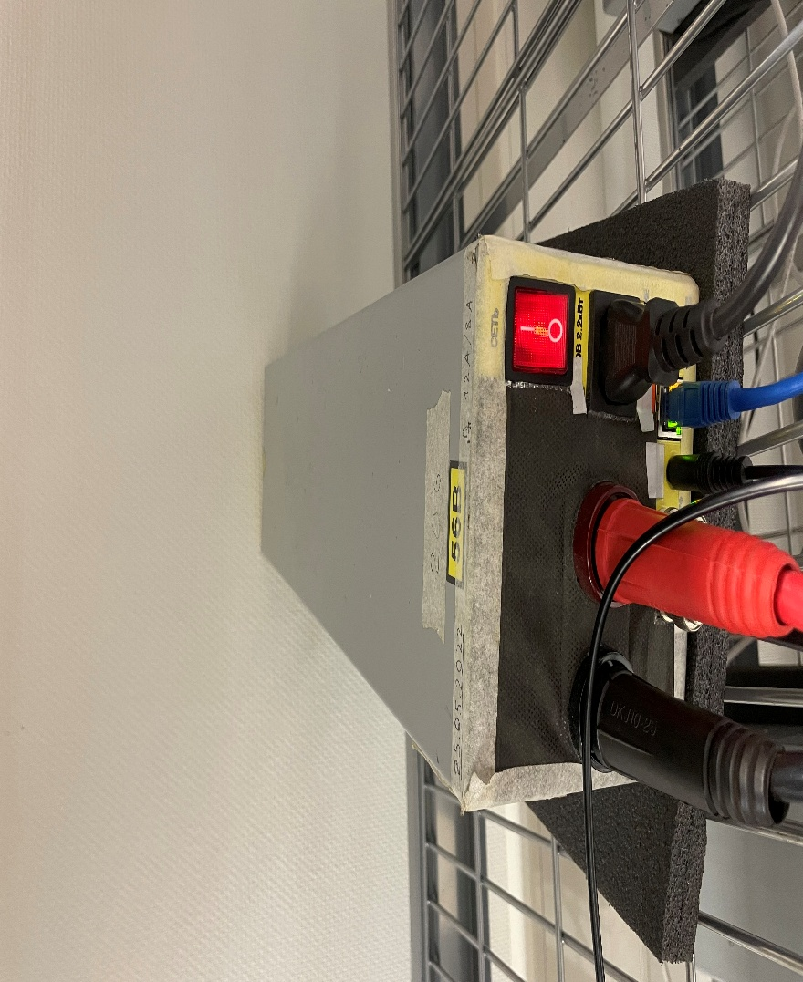
Figure 4: Single Channel Cycler ACK75.48.1750.1.
- Absolute ceiling for safety: 1.75 V per cell software hard stop (50 mV margin to the known ~1.80 V per cell oxidation evolution limit). Never exceed 1.75 V per cell in any automated program.
- Temperature limit: 50 °C. Keep airflow consistent; avoid fan directly on cell unless testing thermal effects.
- Sampling/logging: 100 Hz (Δt = 10 ms) for 12-channel cyclers, 10 Hz for single channel cyclers. Log raw time, current, voltage at native resolution for all dynamic steps. Do not decimate in the instrument; down‑sample only in post‑processing (retain raw files).
- Fixtures & leads: 4‑wire (force/sense) terminating with kelvin connection, per channel. F+ (Force+), F− (Force−), S+ (Sense+), S− (Sense−).
  - For Testing Cells (two 20x50 mm Cu Tabs) – use kelvin clamps.
  - For testing Blocks with Radiators – see Figure 5:
- S+: + radiator, BOTTOM Side Lateral face, 10 ± 2 mm from the stack interface, alligator clipped next to terminal post.
- F+: + radiator, BOTTOM Side Lateral face, lug attached to terminal post.
- S−: − radiator, TOP Side Lateral face, 10 ± 2 mm from the stack interface, alligator clipped next to terminal post.
- F−: − radiator, TOP Side Lateral face, lug attached to terminal post. Mirror symmetry.
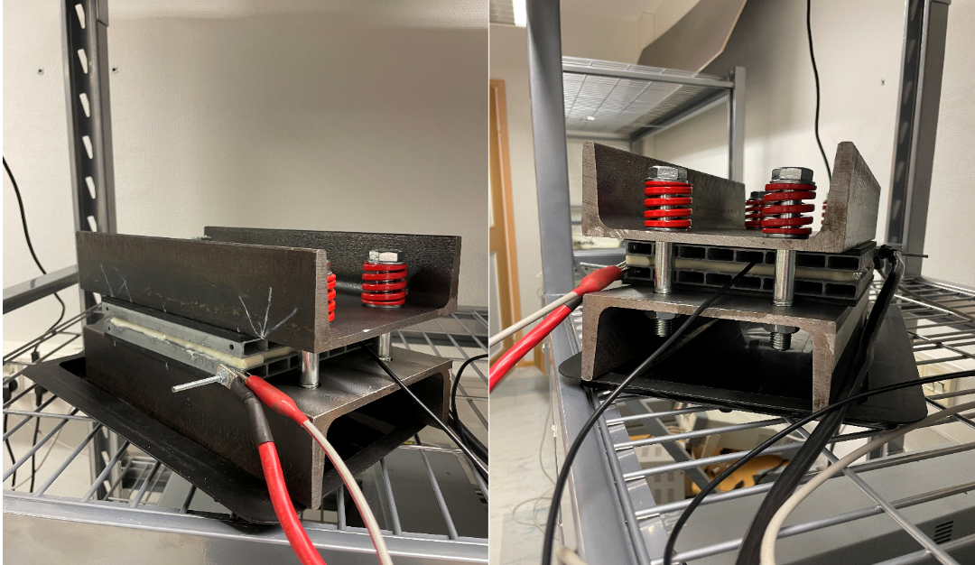
Figure 5: Connections for Blocks.
- Polarity convention: Charge current I > 0, discharge I < 0. Voltage reported as positive full‑cell.
- Rest/relax criterion (pseudo‑OCV): |$\frac{dV}{dt}$ | < 20 mV/min (computed over the last 2 minutes) or fixed 10 min if criterion not reached.
- Safety interlocks (apply to every step):
  - Voltage guards: lower = 0.52 V, upper = 1.72 V (so software catch occurs before hardware limit 0.50/1.75 V targets).
  - Current limit = As per equipment capabilities; see currents table below.
  - Temperature guard (if available): abort if > 45 °C from start of step.

1) Conversion: Current Density ↔ Current (173.24 cm²)
Formula: $I\left[A\right]= j\left[mA.cm^{-2}\right] 0.17324$
j (mA·cm⁻²) | 0.2 | 0.5 | 1 | 2 | 5 | 10 | 20 | 50
I (A) | 0.0346 | 0.0866 | 0.173 | 0.346 | 0.866 | 1.732 | 3.465 | 8.662
*Document any other j → I conversion if used

2) Recommended Overall Order of Testing for Cells
For Production Team:
- Standard Program.
Additional Tests for Research Team:
- EDLC ↔ redox transition mapping (CV multi‑rate).
- Cyclability.
- Leakage Current Test.
- Self-Discharge Test.
Do not reorder unless justified; earlier steps parameterize later ones.

3) Standard Program

3A) Objective
The objective of the test is to inspect the chemistry and determine the Capacitance, Energy, ESR10ms and ESR1s for the cells.

3B) Preparation
- Visually inspect for swelling, leaks, or salt crystallization. Weigh (±0.01 g). Record serial/lot, tabs orientation, and clamp force/fixture type.
- Establish kelvin connections.
- Sample at 100 Hz.
- Use Temperature and Voltage hard limits as discussed in Section 0.

3C) Test Sequence
- Rest 1s.
- 3 Cycles of Cyclic Voltammetry from 0.5V to 1.72V at 10 mV/s.
- Rest 1s.
- Charge CC @ 10 mA·cm⁻² (1.732 A) to 1.70 V (V_{R}).
- CV hold for 10 sec at 1.70V.
- Rest 1s.
- Discharge CC @ 10 mA·cm⁻² to 0.85 V (V_{M}).
- Rest 1s. (Note V_{END}, V_{10ms}, V_{1s})
- Cycle to Step 4, 5 times.
- Discharge CC @ 10 mA·cm⁻² to 0.1 V.
9. Charge CC @2 mA·cm⁻² (346 mA) to 1.72 V
10. Charge CV at 1.72 V for 72 hours (Leave current value empty) - Leakage Current Test.
OR
- Charge CV at 1.72 V for 2 hours disconnect the cell and measure Voltage after 72 hours – Self Discharge Test

3D) Analysis

11. Record Q_{ref}, E_{ref}, ESR_{1s}, and ESR_{10ms} from Discharge Cycle 3 and build OCV-SOC curve.
12. Generate OCV-SOV curve from Charge and Discharge Cycle 3.

4) Primary Objective — EDLC Region & Redox Onset
Use two complementary methods. Report both and require agreement within ≤ 20 mV (charge branch primary).

4A) Multi‑Rate CV with Capacitive Scaling
Rationale. In EDLC, $i\left(V\right)=C\left(V\right) ν$. Thus $Cν(V)=\frac{\left|i(V)\right|}{ν}$overlays for different scan rates. Redox introduces non‑linear, non‑invariant features.
Program: CV Mapping
- Start at 0.50 V (discharge at 0.2 mA·cm⁻² (0.0346 mA) if needed).
- Pre‑conditioned cell from Section 3.
- Scan rates ($υ$ = 1, 2, 3, 4, 5, 6, 7, 8, 9, 10 $\frac{mV}{s}$).
- Sweep 0.50 → 1.72 V → 0.50 V: absolute guard 1.75 V.
- Log i–V at 100 Hz.
Analysis steps:
  - Compute $( C_{V}(V)=\frac{\left|i\left(V\right)\right|}{ν})$ for each $ν$. Smooth with a light SG filter (e.g., window 11–21 samples, poly 2) if noisy; never distort peaks.
  - EDLC criterion: overlays within ±5–10% across $ν$ over a contiguous V‑span.
  - Onset V _{redox, on} first sustained V where overlays diverge (>10% for ≥25 mV span) and/or peaks appear. Optionally compute b‑value: slope of $log \left|i(V)\right|$ vs $log ν$. b ≈ 1 = capacitive; b < 1 trending to ~0.5 = diffusion-limited faradaic. Define onset where b first drops below 0.9 (or your chosen threshold) for >25 mV span. Threshold: b < 0.90 sustained over ≥25 mV indicates faradaic contribution. Define V_{EDLC, max} as the upper V on charge where EDLC criterion still holds.
  - Report both charge and discharge onsets; use charge for operational ceiling selection (more conservative regarding OER risk).
Deliverables:
- i–V plots
- C_{v} (V) overlays
- b(V) (optional)
- V_{EDLC, max}
- V_{redox, on}

4B) Low‑Rate GCD with Differential Capacitance
Rationale. In GCD, pure EDLC has constant $dV/dt$ at fixed$I$; pseudocapacitance increases differential capacitance with $V$.
Program: GCD dC/dV
- CC charge 0.50 → 1.72 V at 2 mA·cm⁻² (0.346 A); CC discharge back to 0.50 V at same $I$.
- Optional repeat at 1 mA·cm⁻² (0.173 A) if needed.
Analysis steps:
    - Numerically evaluate $C\left(V\right)=\frac{I}{\frac{dV}{dt}}$ using finite differences on $V(t)$; compute $\frac{dV}{dt}$ via linear fit in a moving 50–100 ms window to suppress noise.
    - Determine baseline C_{EDLC} (near‑constant region). Define onset where $\frac{dC}{dV}$ exceeds threshold (e.g., >0.5 F·V⁻¹ relative to baseline) or where $C(V)$ deviates >10% from baseline for ≥25 mV.
    - Crosscheck against CV; if |ΔV| > 20 mV, repeat GCD at lower $I$.
- Outcome: Choose routine EDLC‑only upper cutoff = V_{EDLC, max.} For hybrid operation, allow up to 1.72 V but maintain 1.75 V hard stop.

5) Low‑Rate Reference Capacity/Energy (Defines (Q_{ref}, E_{ref}), Build OCV-SOC and SOE map, Determine DC ESR_{10ms} and DC ESR_{1s})
Program: Reference GCD
- 3 cycles CC charge 0.85 → 1.70 V,
- CC discharge 1.72 → 0.80 V at 2 mA·cm⁻² (0.346 A).
- Repeat Step 1 three times.
- Rest 2 min between steps.
Calculate on cycle 3 (discharge branch):
- $Q_{ref} = Q_{dis,3} = \int{I dt}$
- $E_{ref}= E_{dis,3} = \int{VI dt}$
- Coulombic and Energy Efficiencies per cycle
- DC ESR_{10ms} and DC ESR_{1s}
Record these; all SOC/SOE normalizations reference this test and the 0.80 ↔ 1.72 V window.
- SOC (coulombic): with 0% at 0.80 V
$$SOC\left(t\right)=\frac{Q_{in}(t)}{Q_{ref}}×100\%, Q_{in}\left(t\right)=\int_{t_{0}}^{t}{I\left(t\right) dt}$$
Clamp to [0,100] %. Reset (t₀) each time a cutoff is reached. During any rest ≥ 2 min, reconcile SOC by mapping the relaxed voltage to SOC using the OCV(SOC) curve (limit correction to ±2% to avoid over‑snap under hysteresis).
- SOE (state of energy): charge‑accumulated or remaining
  - During charge: $SOE\left(t\right)=\frac{\int_{t_{0}}^{t}{VI dt}}{E_{ref}}×100\%$
  - During discharge: compute remaining SOE by integrating the OCV(SOC) curve from current SOC to 0% (or numerically propagate using instantaneous V as proxy if OCV map is unavailable at that SOC).
Always state reference window (0.80–1.72 V) with SOC/SOE.

6) DCIR at Multiple SOC (Time‑Domain Resistance)
Targets: Extract ohmic (R₀) (fast drop) and 1 s DCIR (R_{1s}) (ohmic + short‑time polarization). With 100 Hz sampling, evaluate using short averaging windows.
SOC setpoints: 20%, 40%, 60%, 80%.
Pulse amplitudes: choose two to check linearity, e.g. 5 and 10 mA·cm⁻² → 0.866 A and 1.732 A.
Program: DCIR at SOC x%
1. Park at target SOC using small CC adjust; rest ≥ 5 min (or until |dV/dt| < 0.5 mV/min). Record baseline V₀ (OCV proxy).
2. Positive pulse: step 0 → +I for 1 s. Compute $∆V\left(t\right)=V_{0}-V(t)$
- R₀: average V over 20–40 ms post‑step (skip the first sample), $R_{0}=\frac{∆V_{30ms}}{I}$
- R_{1s}: average V over 0.9–1.1 s, $R_{1s}=\frac{∆V_{1s}}{I}$
3. Rest 3 min back to V₀ (or to relax criterion).
4. Negative pulse: 0 → −I for 1 s; compute R₀, R_{1s} identically.
5. Repeat steps 2–4 at the second amplitude. Verify linearity: $∆V∝I$. If non‑linear, report resistance vs I as well.
Outputs: R₀^{+/-}(SOC), R_{1s}^{+/-}(SOC), averages, and optionally R_{10s}^{+/-}(SOC) using 9.9–10.1 s window.
IR‑correction for cutoffs: $V_{corr}=V-IR_{0}$ useful near 1.72 V to avoid artificial early cutoff.

7) Capacity Retention (CR) Long Cycling
Window: 0.80 ↔ 1.72 V (or EDLC‑only upper limit from Section 4 for an EDLC‑focused campaign).
Program: CR cycling
- Set current density typical of use, e.g. 5 mA·cm⁻² (0.866 A).
- For N cycles (e.g., ≥ 10000):
1. CC charge to 1.72 V; rest 2 min.
2. CC discharge to 0.80 V; rest 2 min.
- Every 1000 cycles: insert a CV hold at 1.60 V for 30 min to log leakage current.
Log temperature and leakage trend separately.

8) Copy‑Paste Cycler Programs (Pseudocode Style)
- Program P1 — Pre-Conditioning & CV EDLC/Redox Mapping
1. If U > 0.50 V: Go to Step 2
2. Discharge CC @ 0.2 mA·cm⁻² (34.6 mA) to 0.50 V
3. Rest 10 min.
4. Charge CC @ 0.5 mA·cm⁻² (86.8 mA) to 1.39 V
5. Rest 2 min.
6. Discharge CC @ 0.5 mA·cm⁻² (86.8 mA) to 0.50 V
7. Rest 2 min.
8. Cycle to Step 4, 5 times.
9. Rest for 10 min after Pre-conditioning cycles are completed.
10. For ν (scan rate) in {1, 2, 4, 5, 6, 7, 8, 9, 10} mV·s⁻¹: - CV sweep 0.50 → 1.72 V → 0.50 V; guards 0.48/1.75 V; sample 100 Hz.
- Program P2 — Reference GCD (Q_{ref}/E_{ref}), SOC/OCV Curve and ESR (10ms and 1s) estimation
1. If U > 0.80 V: Go to Step 2
2. Discharge CC @ 0.2 mA·cm⁻² (34.6 mA) to 0.80 V
3. Rest 10 min.
4. Charge CC @ 2 mA·cm⁻² (346 mA) to 1.72 V
5. Rest 2 min.
6. Discharge CC @ 2 mA·cm⁻² (346 mA) to 0.80 V
7. Rest 2 min.
8. Cycle to Step 4, 3 times.
9. Charge CC @2 mA·cm⁻² (346 mA) to 1.72 V
10. Charge CV at 1.72 V for 72 hours (Leave current value empty) - Leakage Current Test.
OR
10. Charge CV at 1.72 V for 2 hours disconnect the cell and measure Voltage after 72 hours – Self Discharge Test
11. Record Q_{ref}, E_{ref}, ESR_{1s}, and ESR_{10ms} from Discharge Cycle 3 and build OCV-SOC curve.
12. Generate OCV-SOV curve from Charge and Discharge Cycle 3.
- Program P3 — DCIR vs SOC For SOC {20, 40, 60, 80} %:
- Adjust to SOC; rest ≥5 min.
- Pulse +I₁ (5 mA·cm⁻²) for 10 s; rest 3 min.
- Pulse −I₁ for 10 s; rest 3 min.
- Pulse +I₂ (10 mA·cm⁻²) for 10 s; rest 3 min.
- Pulse −I₂ for 10 s; rest 3 min.
- Program P4 — Capacity Retention (CR) or Long term Cycling
Repeat N cycles:
1. CC charge to 1.72 V @ 10 mA·cm⁻²; rest 2 min.
2. CC discharge to 0.80 V @ 10 mA·cm⁻²; rest 2 min.
Every 100 cycles: CV hold 1.60 V for 30 min (record leakage).

